Collaborative Practice Agreement:
Physician Referral for Comprehensive Medication Review and Assessment – Example 2

Introduction and Scope:
Asthma is a complex medical condition which often requires close monitoring, medication management, drug dose titration, and patient/caregiver education. The National Heart Lung and Blood Institute (NHLBI), under the guidance of the National Institutes of Health (NIH), has published guidelines directing the care of patients with asthma.¹ These guidelines recommend pharmacists be included as part of the care team to ensure patients achieve asthma control. [Insert Name of Pharmacy] is part of the Wisconsin Pharmacy Quality Collaborative² which is committed to improving health outcomes and reducing health care costs by aligning with evidence-based guidelines. Participating pharmacies and their pharmacists must adhere to a set of quality standards³ designed to increase the quality of pharmacy services provided and maximize patient safety in the medication use process. The ultimate goal of WPQC is to resolve drug therapy problems, improve adherence, and engage patients in their own care. To that end, it is recognized that patient confusion results from conflicting instructions coming from different providers; thus, the scope of this CPA is to help manage the prescribed medication regimen and make dose adjustments in accordance with established guidelines. Requests for changes in therapy must be handled through the prescribing physician. [Insert Name of Pharmacy] routinely provides Medication Therapy Management (MTM) services and is interested in entering into this CPA.

Purpose
Wisconsin state law allows pharmacists to practice under a Collaborative Practice Agreement with individual physicians (Statute 450.033 Services delegated by physician: A pharmacist may perform any patient care service delegated to the pharmacist by a physician, as defined in s. 448.01(5).
448.01 Definitions. In this chapter: (5) ”Physician” means an individual possessing the degree of doctor of medicine or doctor of osteopathy or an equivalent degree as determined by the medical examining board, and holding a license granted by the medical examining board.
It is the intent of this document to authorize the pharmacists employed by [Insert Name of Pharmacy] to work in a collaborative fashion with and under the direct supervision of the physician(s) listed below. This document establishes a framework and guidelines for collaboration between the physician and pharmacist.

Goals
The goals of this agreement are to:
- Allow pharmacists to conduct a Comprehensive Medication Review and Assessment (CMR/A) session with patients who have asthma that may be sub-optimally controlled (as defined below).
- Improve efficacy of asthma regimen by monitoring adherence, proper device use, and patient response to currently prescribed medications/therapies.
- Enhance patient/caregiver understanding of their prescribed medication regimen.
- Formulate recommendations to optimize therapy, when appropriate.
- Assess and triage potential and significant adverse drug reactions to the physician(s) named in this agreement.
- Increase collaboration between [Insert Name of Pharmacy] and the physicians named below.

Policy:
Patients who may have sub-optimally controlled asthma as defined by the statements immediately below may be evaluated by the pharmacist for an initial CMR/A. Patients who have received an initial CMR/A are automatically eligible to receive follow-up visits, if necessary.
There are three main points of contact by which pharmacists can initiate a CMR/A with a patient. Any of the following criteria can prompt the provision of a CMR/A:
- Medication refills:
- Refills of short-acting beta-agonist (SABA) exceeding 2 canisters (200 puffs per canister) in 90 days.
- Refills of monthly asthma controller medications less than 3 times in the past six months.
- Perhaps the most significant impact pharmacists can have on asthma care is to monitor for “bursts” (short courses of 5-10 days) of oral corticosteroids, as patients might be going to multiple Urgent Care clinics for weekend or after hours care, and the patient’s physician is unaware of the true number of corticosteroid bursts the patient is receiving from all sources for their asthma. Two courses of oral corticosteroids for asthma exacerbations should trigger a CMR/A.
- When a patient refills an asthma inhaler, it is appropriate for the pharmacist to state, “If you like, you could take a dose of your inhaler right now for me to see how well you’re using it, and we can review tips to use it more effectively if I see any problems. I’m happy to help you and your doctor make sure you’re getting the maximum benefit from this medication.” Given the increasing variety of inhalation devices available, ensuring proper technique will be invaluable in optimizing medication regimens.

- Pharmacist assessment of asthma control, when an asthma patient is requested to complete the ACT™ or Childhood ACT™. Completion of this patient-centered asthma outcome tool is strictly voluntary; the pharmacy cannot require the completion of an asthma assessment as a condition of refilling asthma medications.
- Asthma Control Test™ or Childhood Asthma Control Test™ score of <19. [See Appendix 1]

- Becoming aware, through patient comments or prescription patterns, of a recent episode of urgent or emergent asthma care.
- Recent (within 14 days) discharge from the hospital or emergency department due to an asthma exacerbation.

The CMR/A consists of a face-to-face visit with the patient (and/or the patient’s caregiver) to:
- Assess/review prescription and over-the-counter medications for interactions and duplications.
- Review and promote medication adherence with the prescribed regimen, particularly as it relates to tolerability of various medications and how this might negatively impact adherence. Work with the patient/caregiver to overcome potential barriers, and communicate the insurmountable ones to the physician.
- Review medication device usage and provide reinstruction if needed. Consistent with Scope above, care must be taken to not conflict with the prescribing physician’s instructions. If during the course of a CMR/A a patient comments that the device usage as demonstrated by the pharmacist is not what the physician described, the issue will be dropped, and the pharmacist may subsequently confer with the physician for clarification prior to future CMR/As. There may be reasons for specific instructions by the physician (e.g., closed- vs open-mouth MDI technique, closure of the contralateral nostril or not when using aerosol nasal corticosteroid sprays, etc.), and it is important to not give the patient conflicting advice.
- Explore more cost effective medication regimens, and communicate potential therapeutic substitutions to the prescribing physician. Again to avoid patient confusion, this assessment must be performed in a constructive manner, as not all medications within a therapeutic class will have equal efficacy for a given patient. Comments such as, “This other medication would probably work just as well for you, but your doctor wants you to spend an extra $30 per month on this one,” would interfere with the intended collaborative spirit of this agreement. A better approach would be, “There are similar medications for which your co-pay would be less, but I will first discuss it with your physician so s/he can decide whether the switch might be appropriate for you.”
- Monitor medication efficacy by reviewing the components of asthma control (Appendix 2) with the patient. This assessment provides an excellent access point to ensure that the patient is periodically having spirometry performed, and empowers the patient to be more involved in their own care by reviewing how well they understand their lung health by remembering and understanding their spirometry results. However, unless the pharmacist is a Certified Asthma Educator and has entered into a separate agreement with the physician, the scope of the available interventions is limited to the pharmacotherapeutic explorations detailed above. Recognizing that much of the failure of asthma control is due to poor patient follow-up with their primary care physician, it is reasonable for the pharmacist to suggest a referral to an allergist to both the patient and physician if the patient is found to still be poorly controlled at the third CMR/A, after sending suggestions for therapeutic enhancements to the physician twice before. Further, recognizing that the accurate identification of allergic triggers is much more complex than simply ordering a set of RASTs or Immunocaps, discussions of trigger avoidance measures are to be avoided unless/until the patient has had an evaluation with an allergist and the results of this consultation have been transmitted to the physician and pharmacist.

At the conclusion of each CMR/A, the patient will receive a Medication Action Plan which addresses any identified problems from the CMR/A, as well as an updated Personal Medication List. The physician will receive this visit summary, an updated list of all the medications/OTCs the patient is taking, as well as a summary of the patient’s refills of asthma controller and reliever medications in the past 12 months. This communication may or may not include recommendations for change. Pharmacists are not allowed to make any changes to the patient’s medication regimen without health care prescriber approval. Pharmacists will strongly encourage patients to see their physician for follow-up care or when concerns arise. The care provided by the pharmacist is designed to complement, not replace, the usual and standard care provided by the patient’s physician.

This agreement is voluntary and may be terminated via written request at any time by either party. This document will be reviewed by both parties at least [annually or insert other time frame here].

Signatures of participating physicians:

This agreement is effective date as of the dates set forth below:
Physician Name: _________________________________________ State License Number: _____________________
Physician Signature: ______________________________________ Date Signed: _____________________________

Physician Name: _________________________________________ State License Number: _____________________
Physician Signature: ______________________________________ Date Signed: _____________________________

References:
- EPR. Expert panel report 3: Guidelines for the diagnosis and management of asthma (EPR 2007). NIH Publication Number 08-5846. Bethesda, MD: U.S. Department of Health and Human Services; National Institutes of Health; National Heart, Lung, and Blood Institute; National Asthma Education and Prevention Program, 2007.
- The Pharmacy Society of Wisconsin. Welcome to WPQC. Available at www.pswi.org/wpqc, Accessed February 9, 2015.
- Wisconsin Pharmacy Quality Collaborative (WPQC) Medication Therapy Management (MTM) Services Program. 23 April 2014. Available at http://www.pswi.org/Portals/17/WPQC/Wisconsin%20Pharmacy%20Quality%20Collaborative%20Medication%20Therapy%20Management%20Services%20Program.pdf, Accessed February 9, 2015.

Appendix 1:
Adult Asthma Control Test:
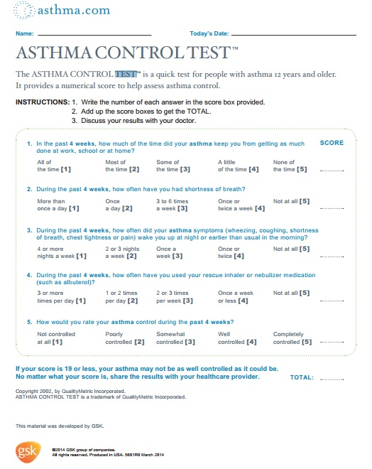

Childhood Asthma Control Test:
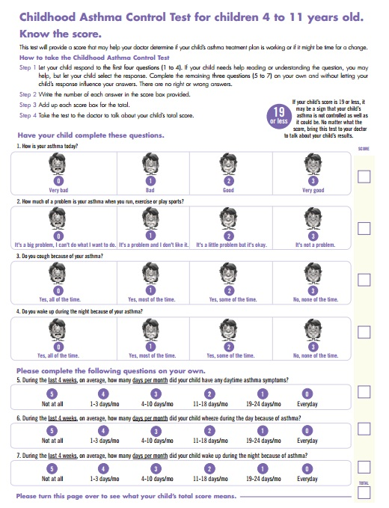

Appendix 2:

Assessing Asthma Control and Adjusting Therapy in Youths >12 Years of Age and Adults¹
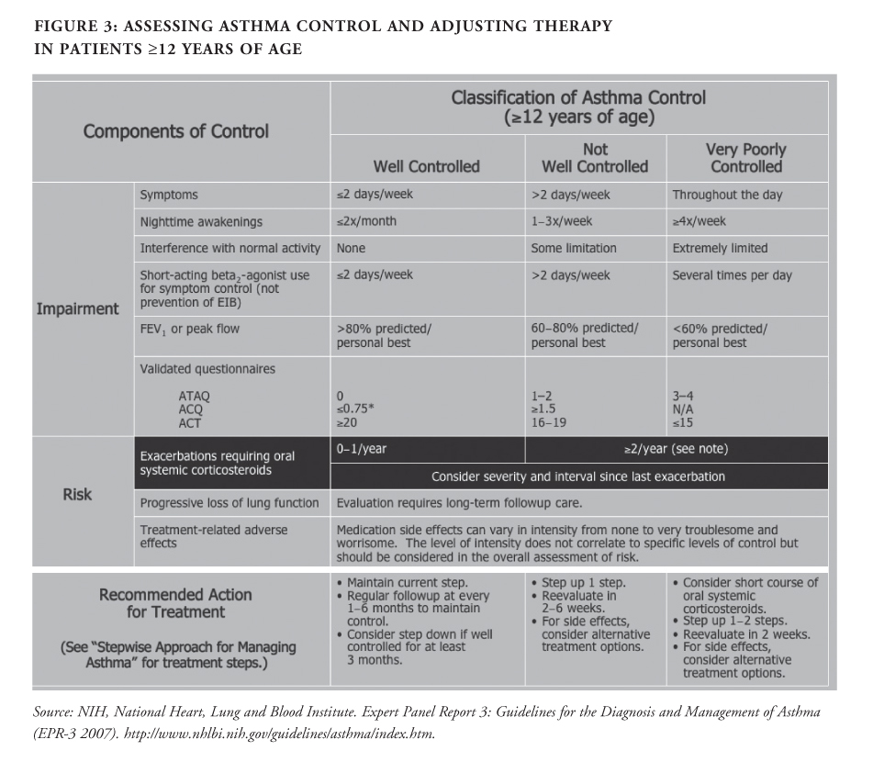

Assessing Asthma Control and Adjusting Therapy in Children¹

